**Banking App with Microservices**

**Account Service:**

1. **Creating new account**

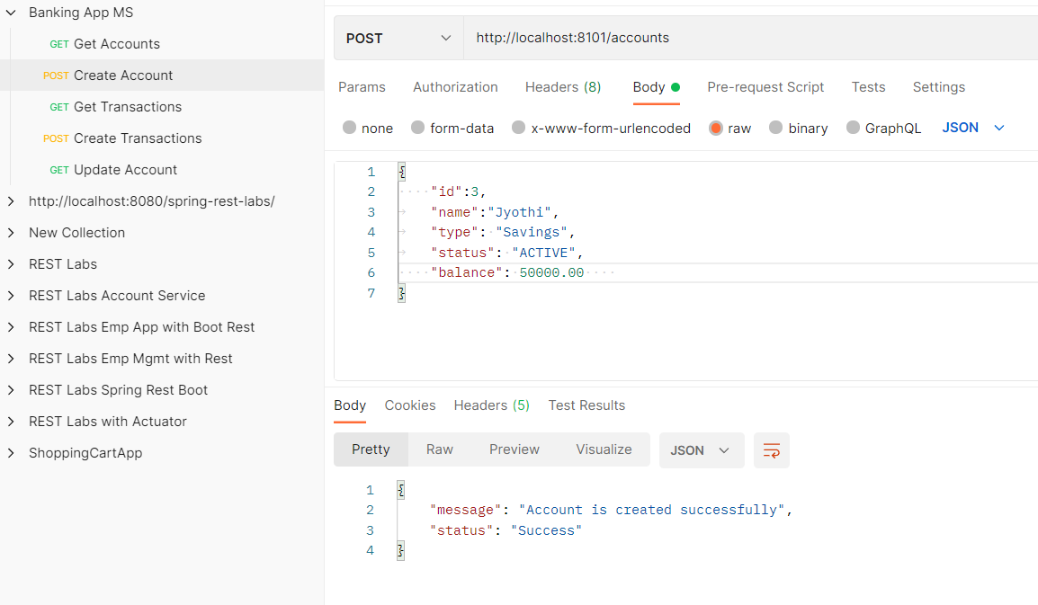

1. **Deleting an account**

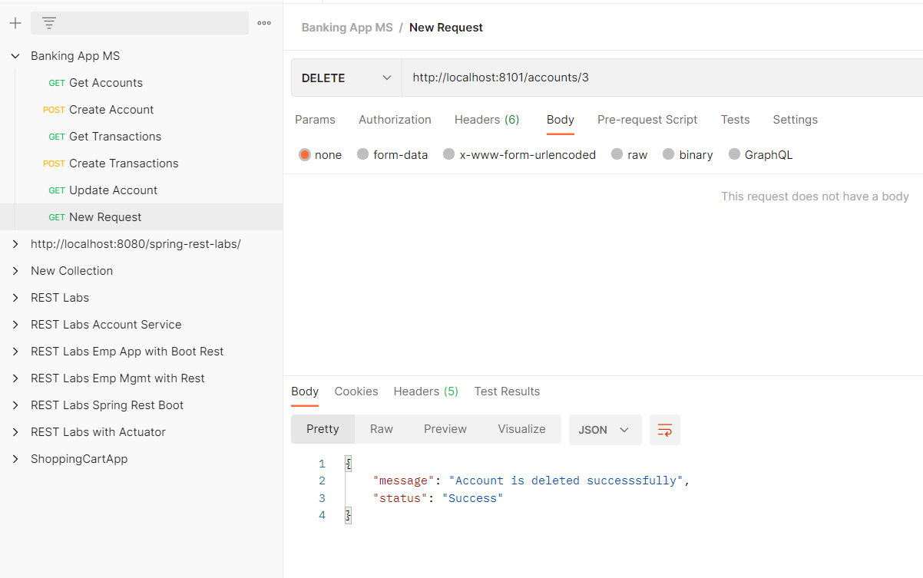

1. **Updating account**
2. 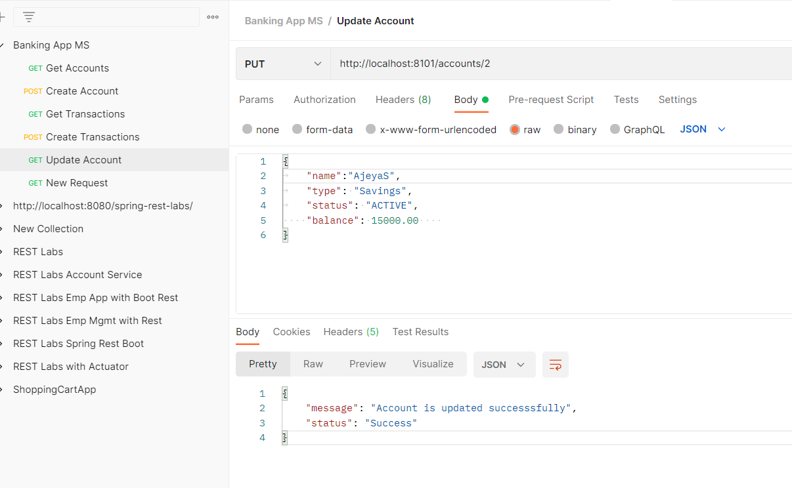
3. 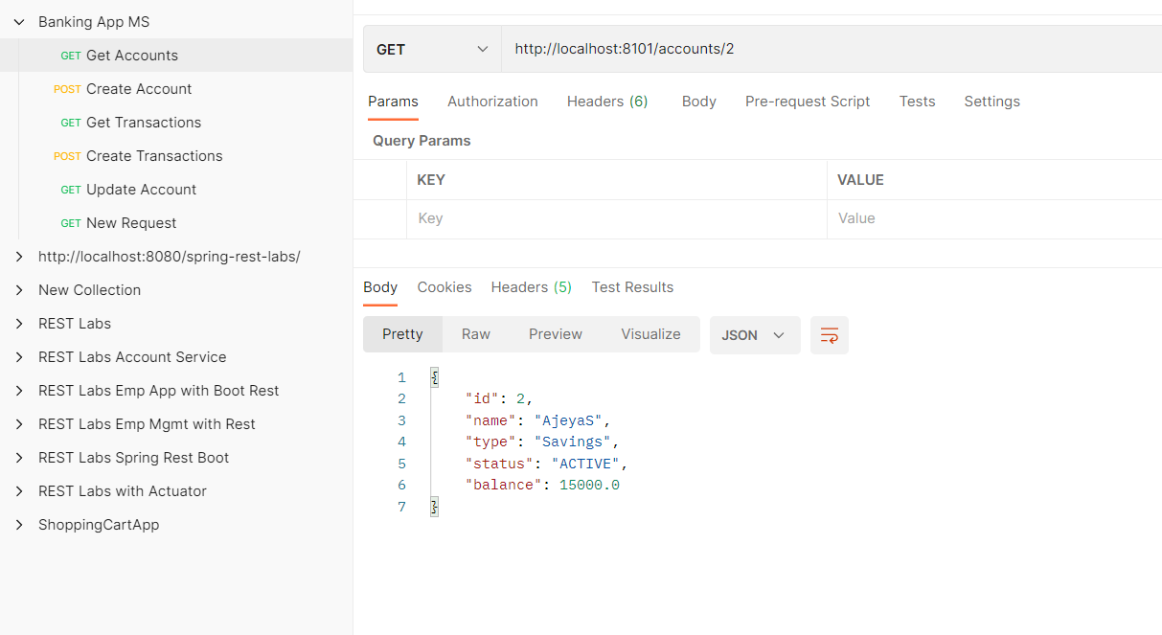
4. **Show all Account**

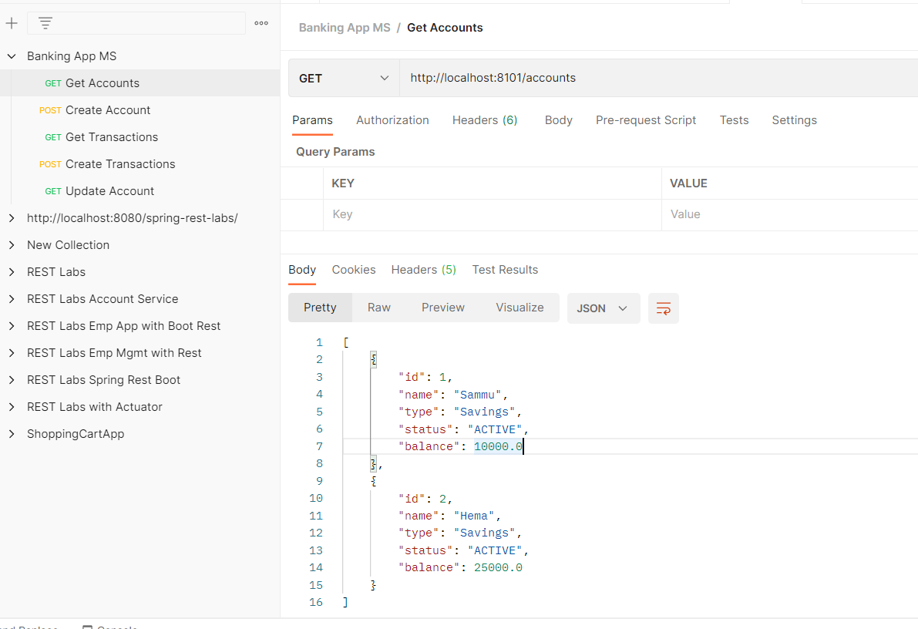

1. **Show account based on acct number**

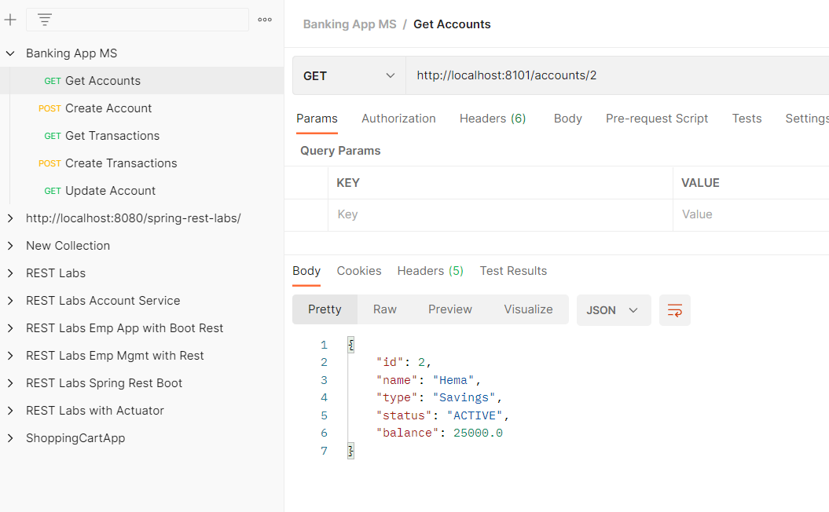

**Transaction Services**

**Get Transactions:**

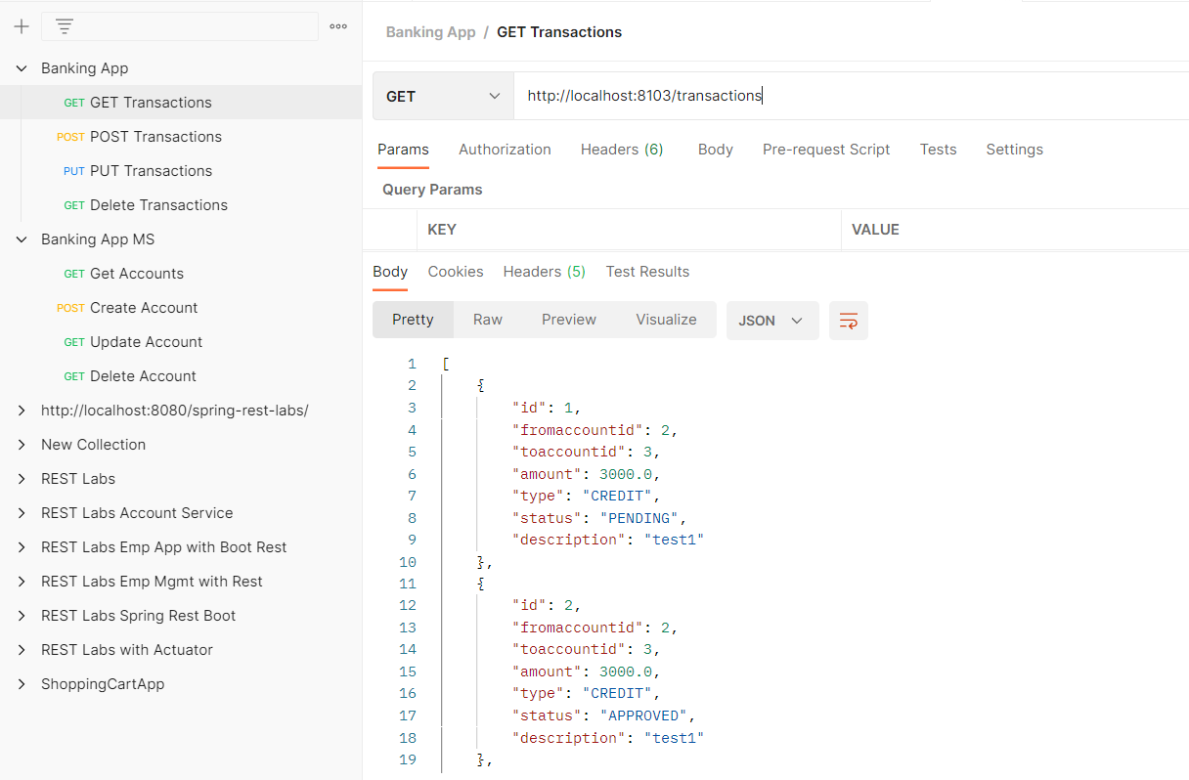

**Get Transaction by ID**

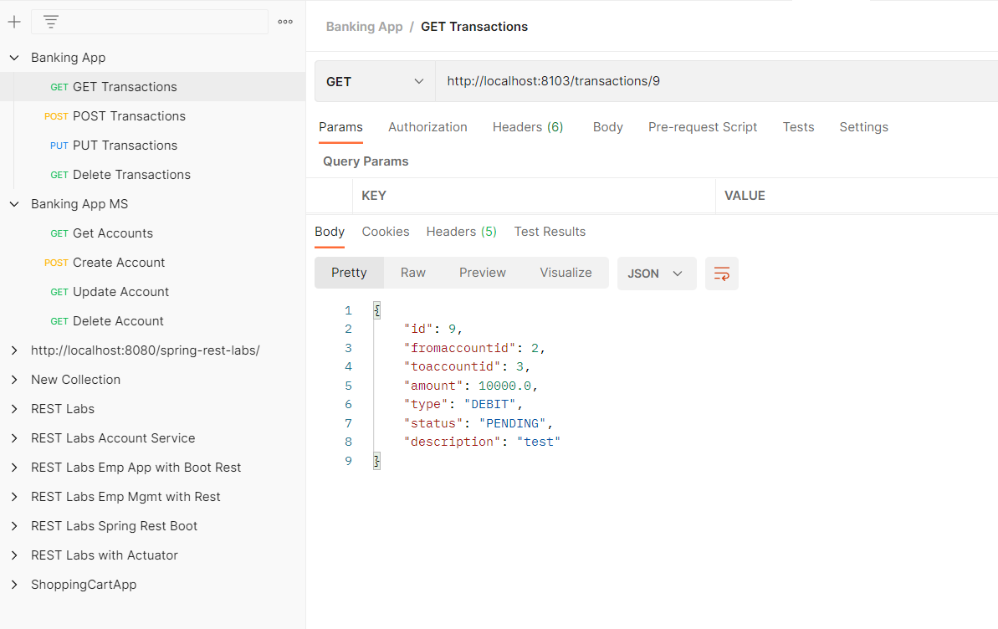

**Transaction Created**

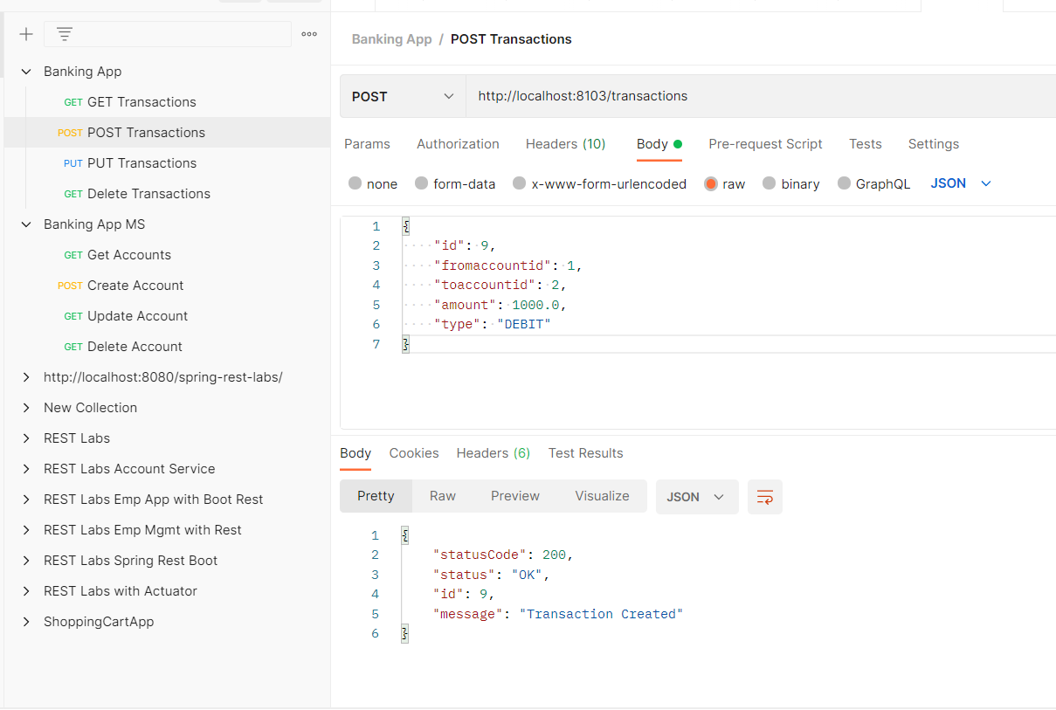

**Transaction Deletion**

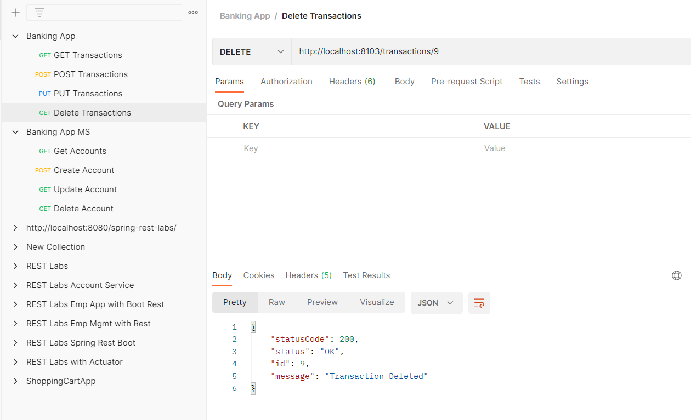

**Transaction Updated**

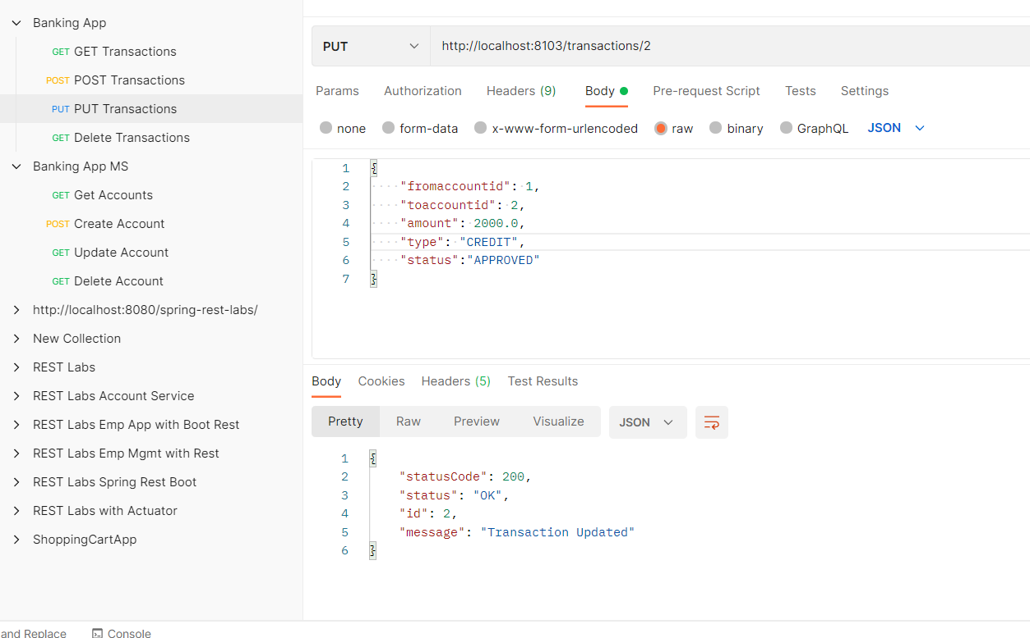

**TRANSACTION APPROVAL N REJECTION SCENARIOS**

**Before Initiating the transaction: Account Balances in accounts table**

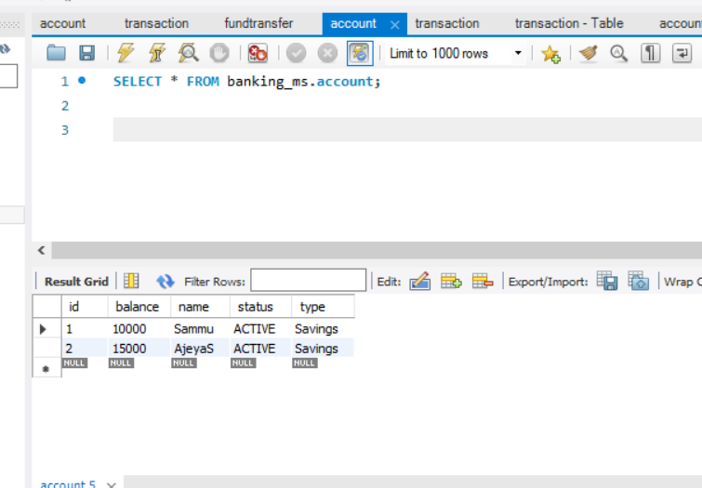

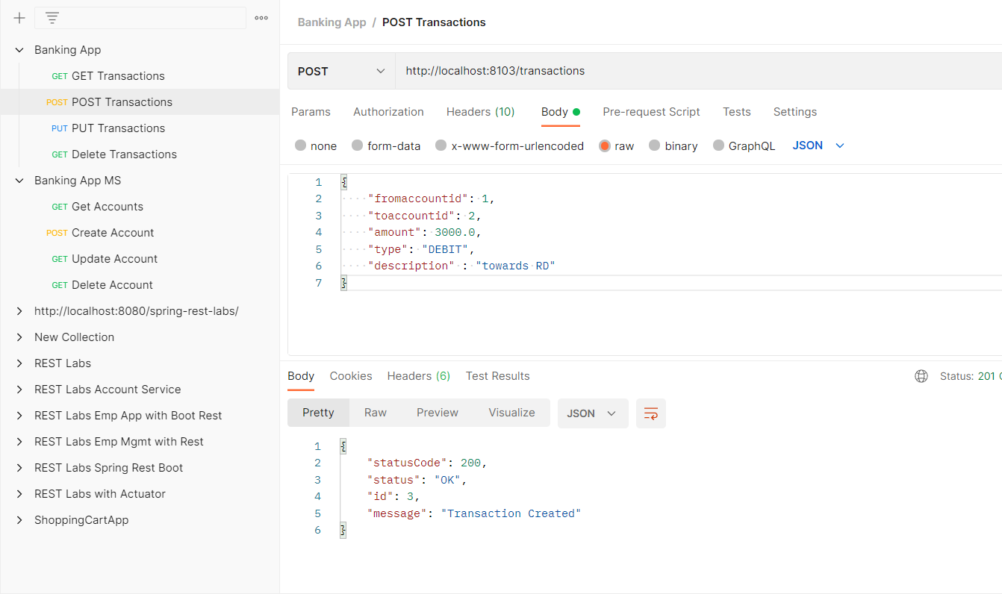

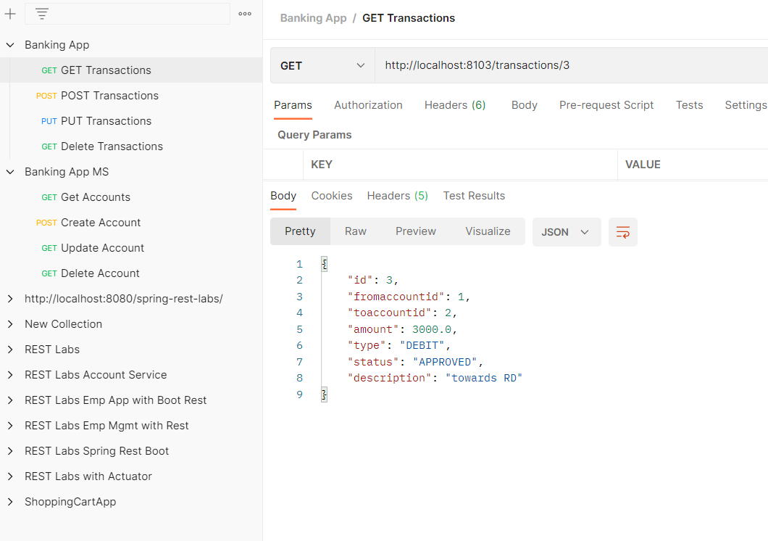

**After Transaction Approval, Balances getting updated**

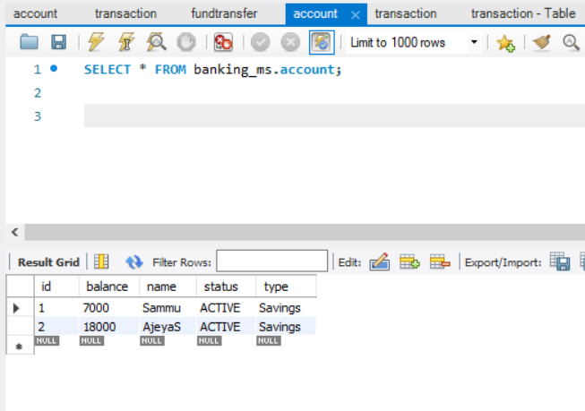

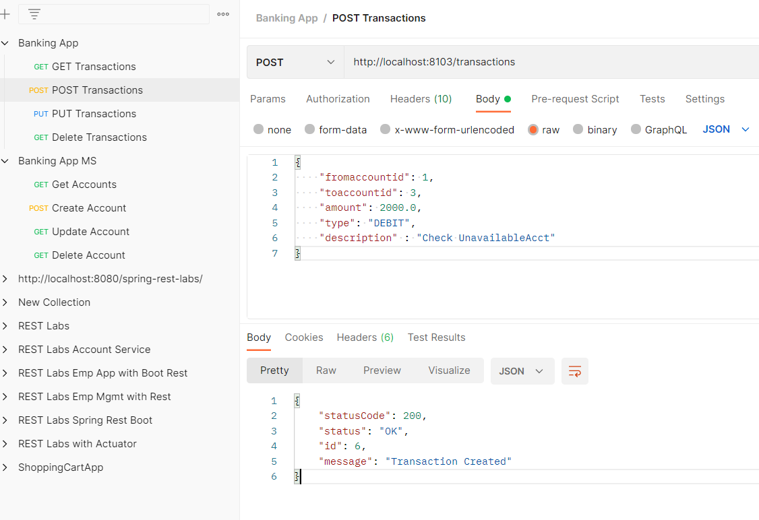

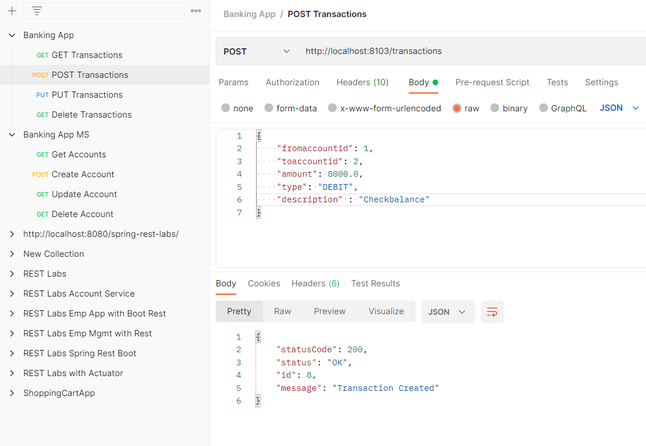

**Compensatory Logic Working for rejected entries as below**

**Transaction from the low balance account to another, gets rejected and transaction table gets added with another record with Rejection and accounts are not updated.**

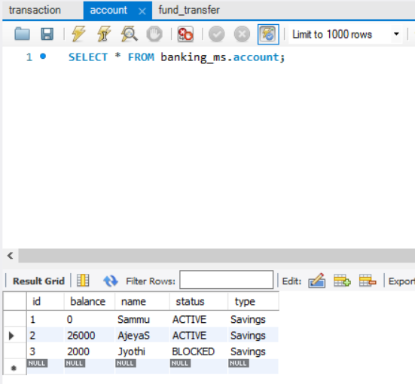

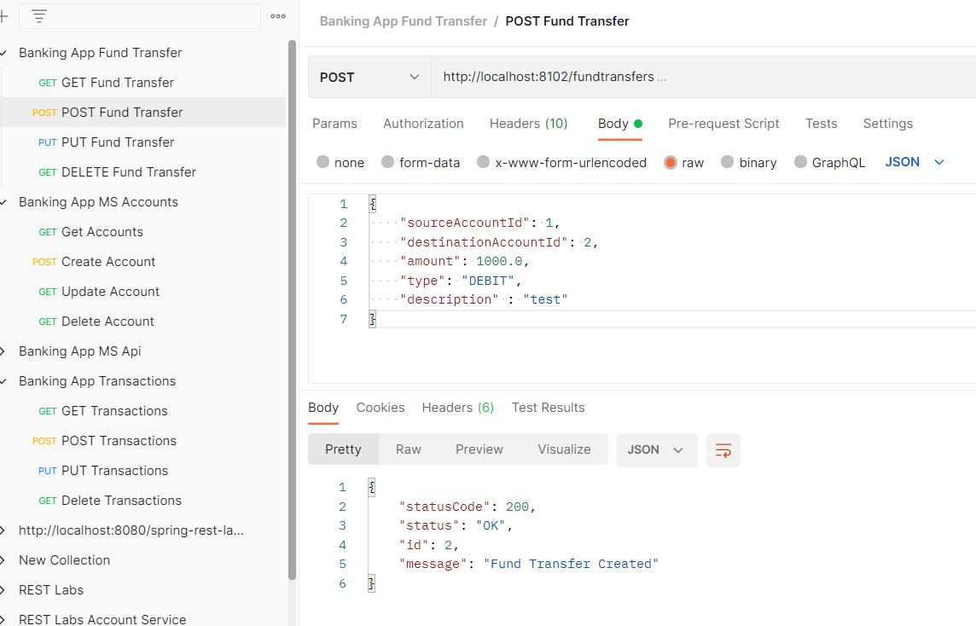

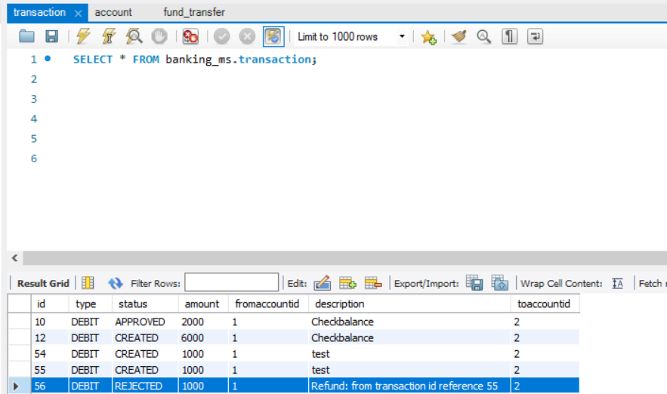

**If the Account status is BLOCKED, then the transaction will be REJECTED and refunded back to source account**

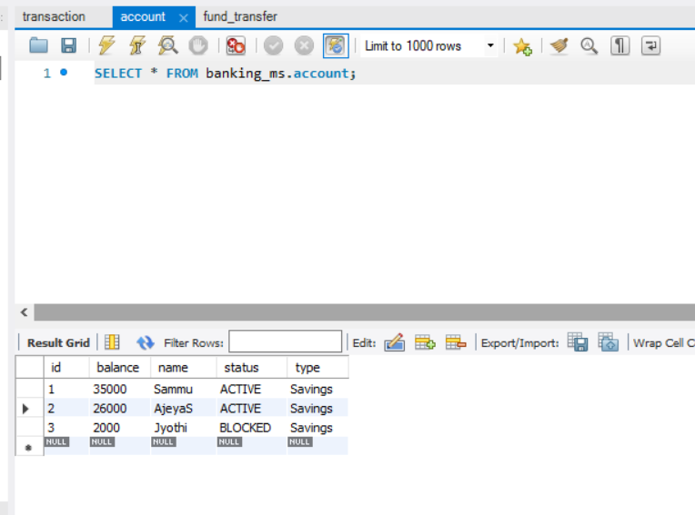



**Eureka running all the services**

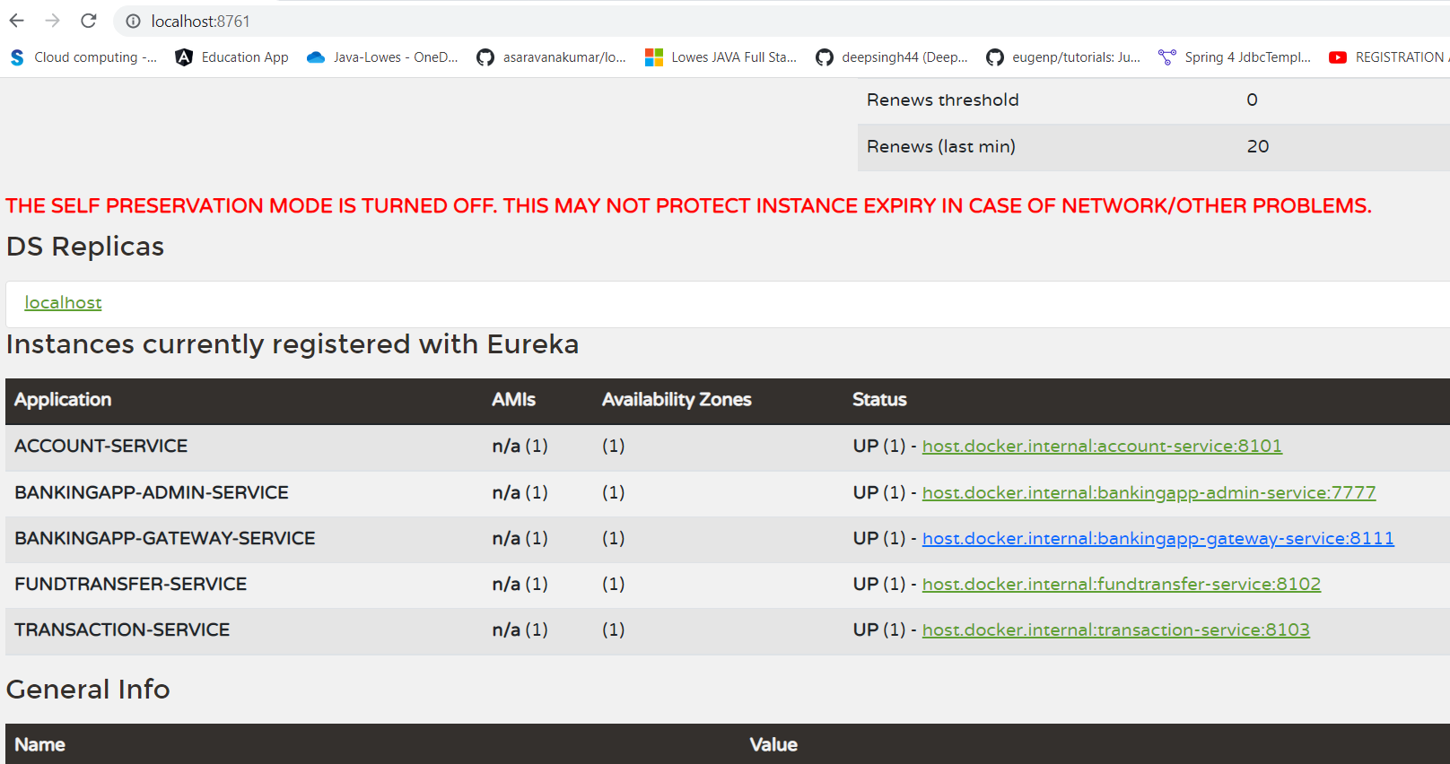

**Admin Services Showing all the services**

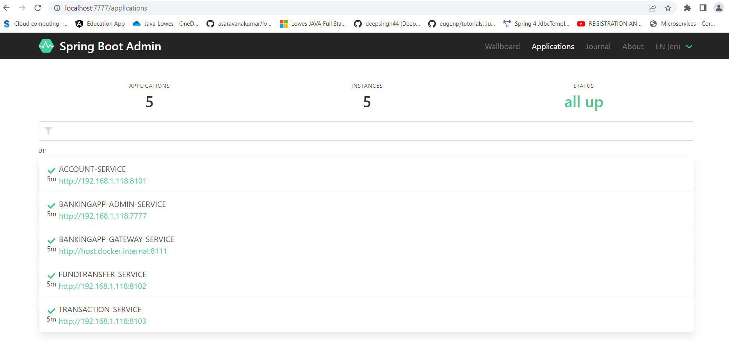

**Test cases for Account Service**

**Context Testing**

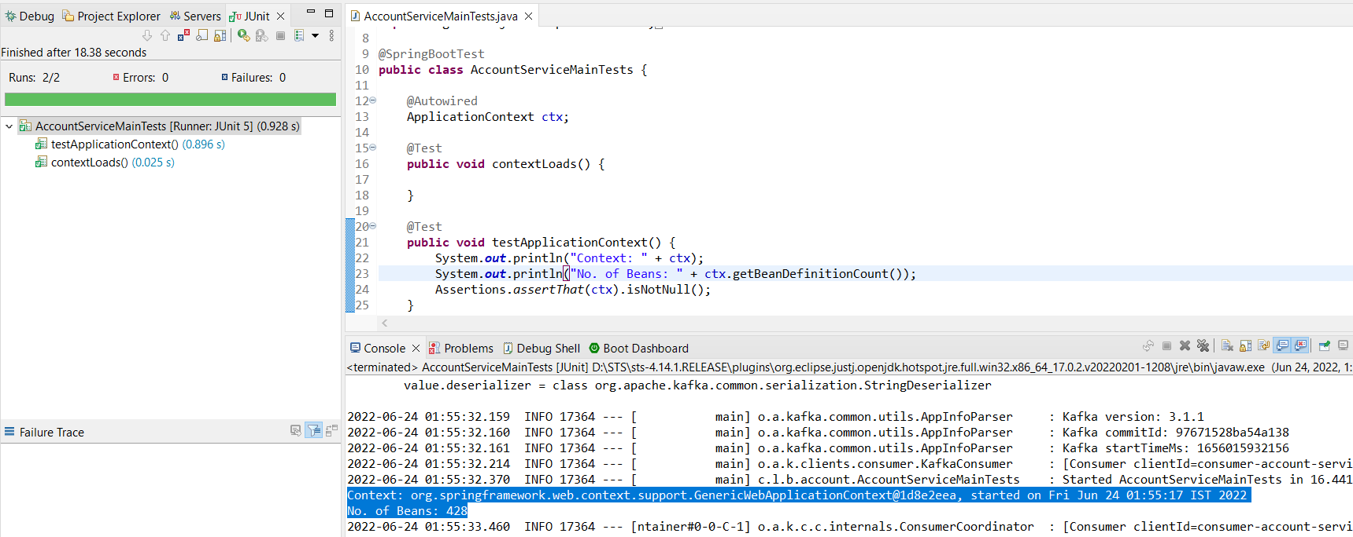

**Integration Testing for Accounts Service**

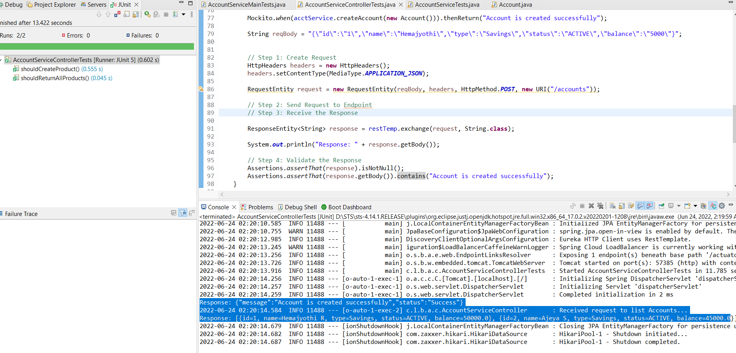

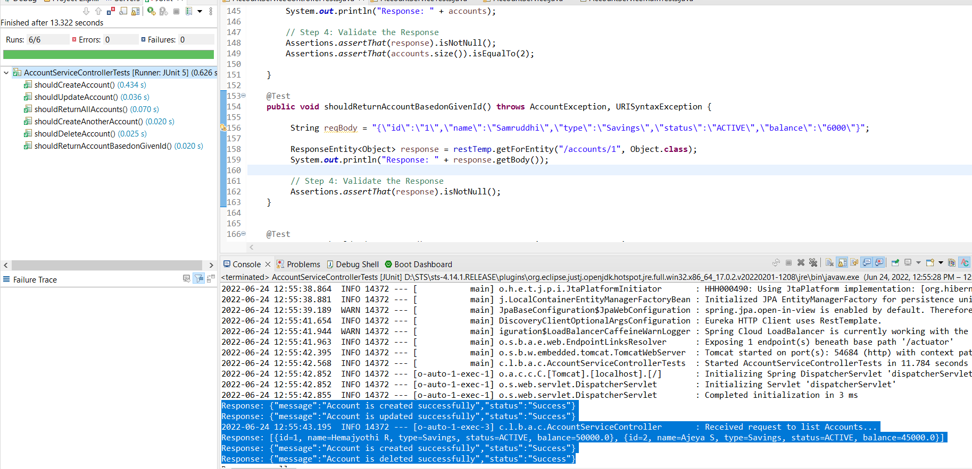

**Unit Test Cases Accounts Service**

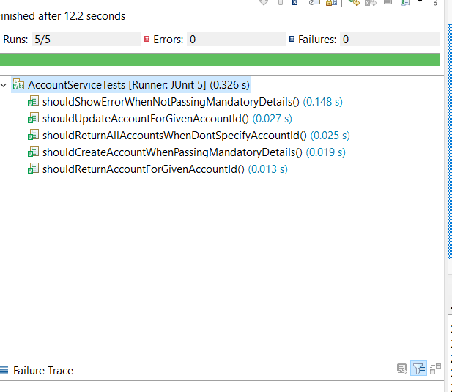

**Test Cases for Transaction Service**

**Application Context**

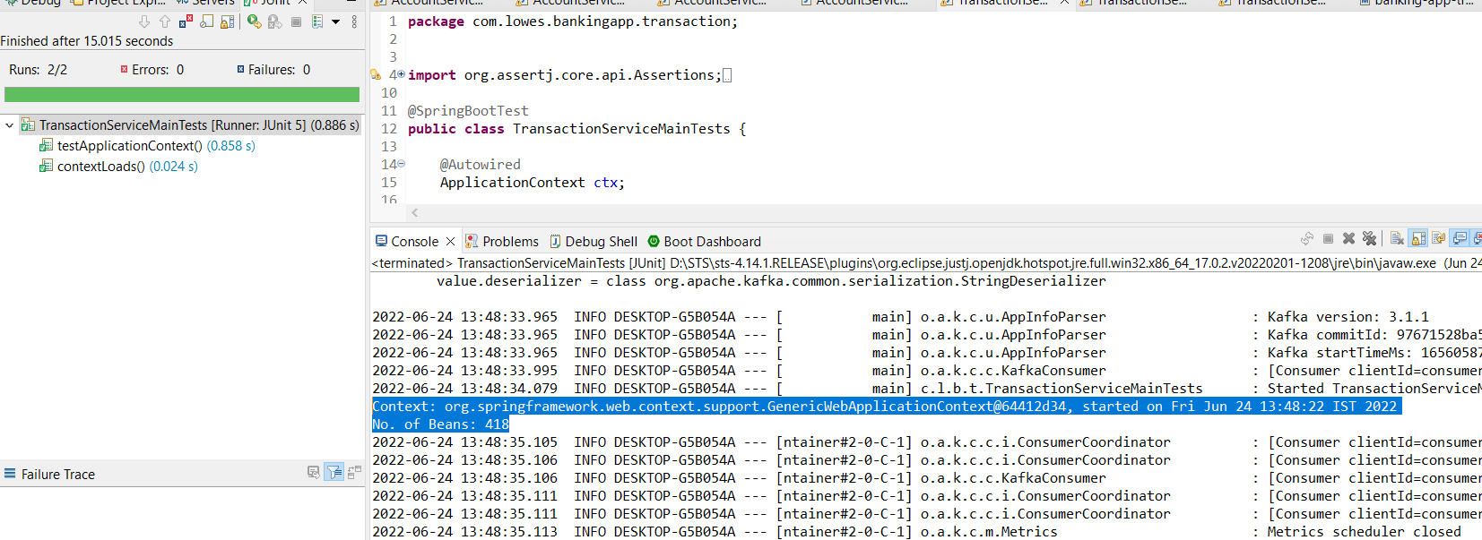

**Integration Tests for Transaction Services**

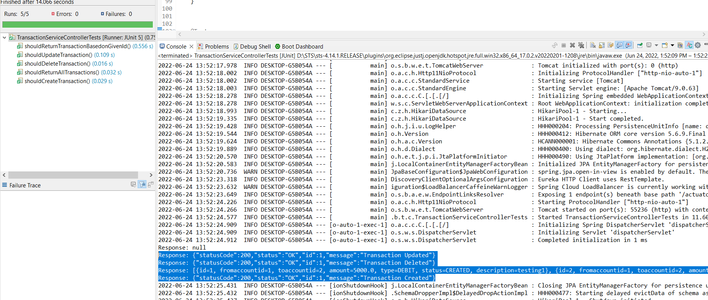

**Unit Tests for Transaction Services**

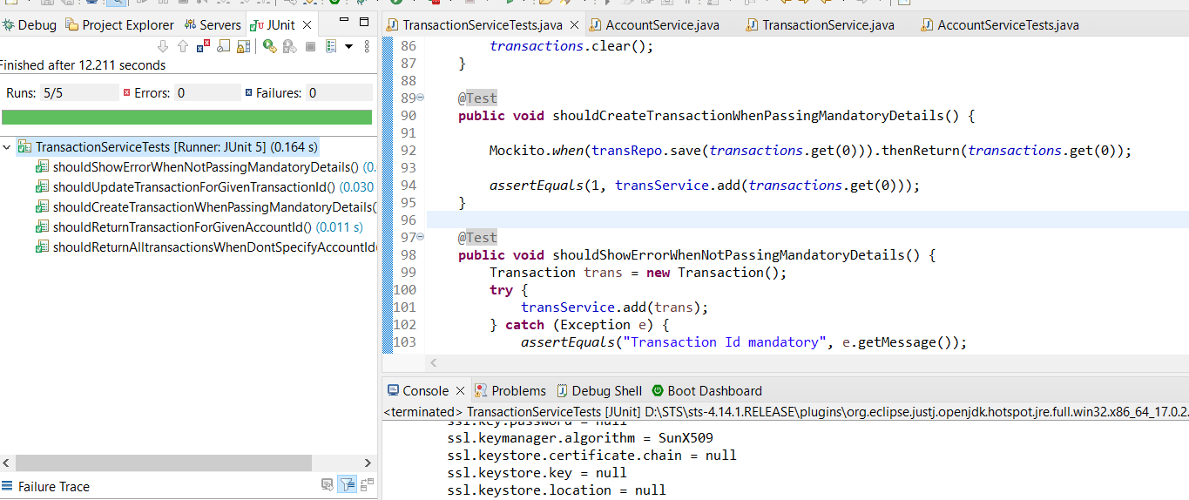

**Fund Transfer service Test cases**

**Application context**

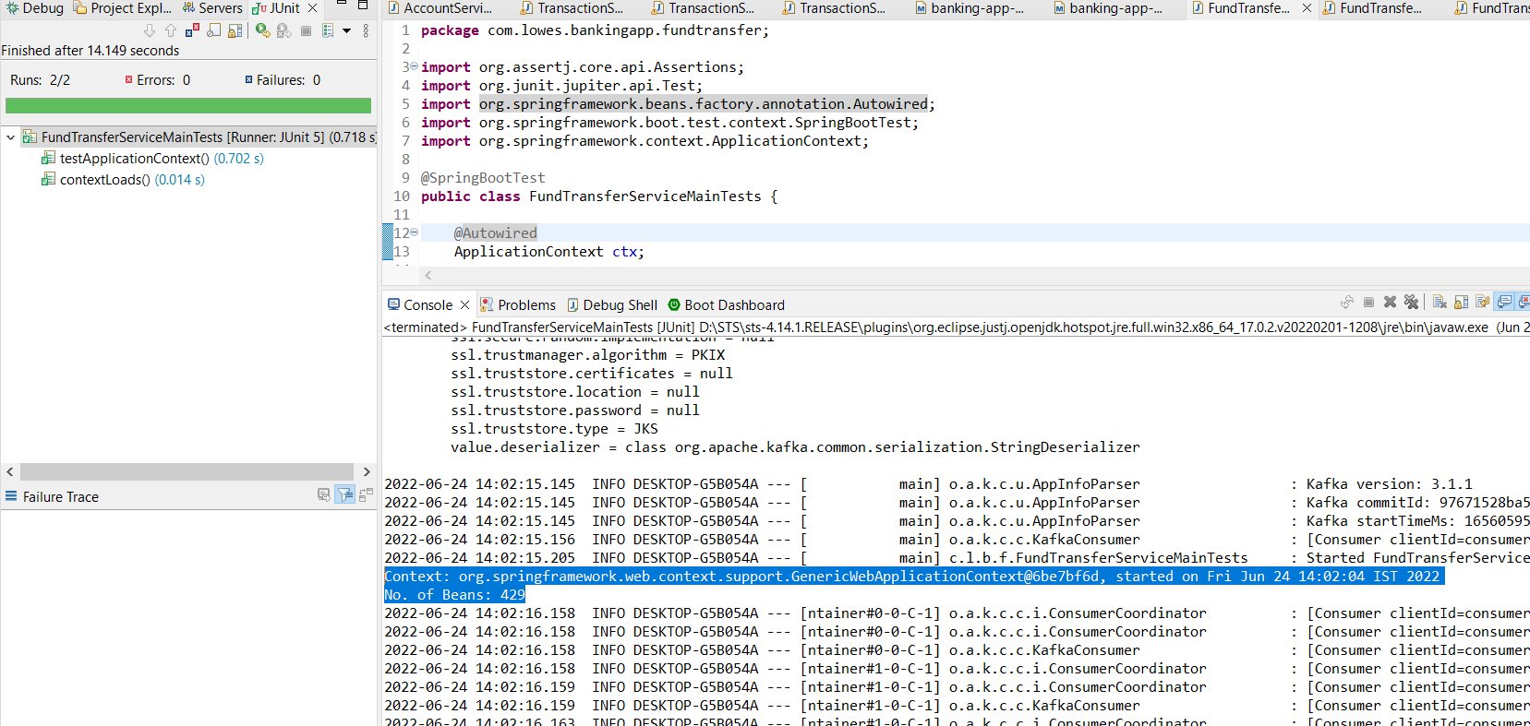

**Integration Tests for Fund Transfer Services**

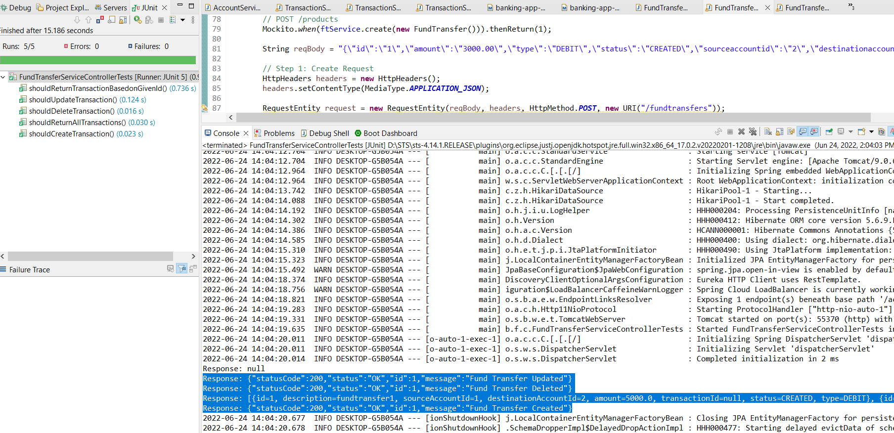

**Unit Test cases for Fund Transfer Services**

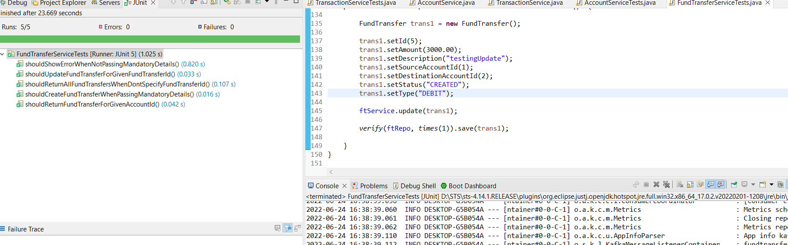

**Services running on Eureka**

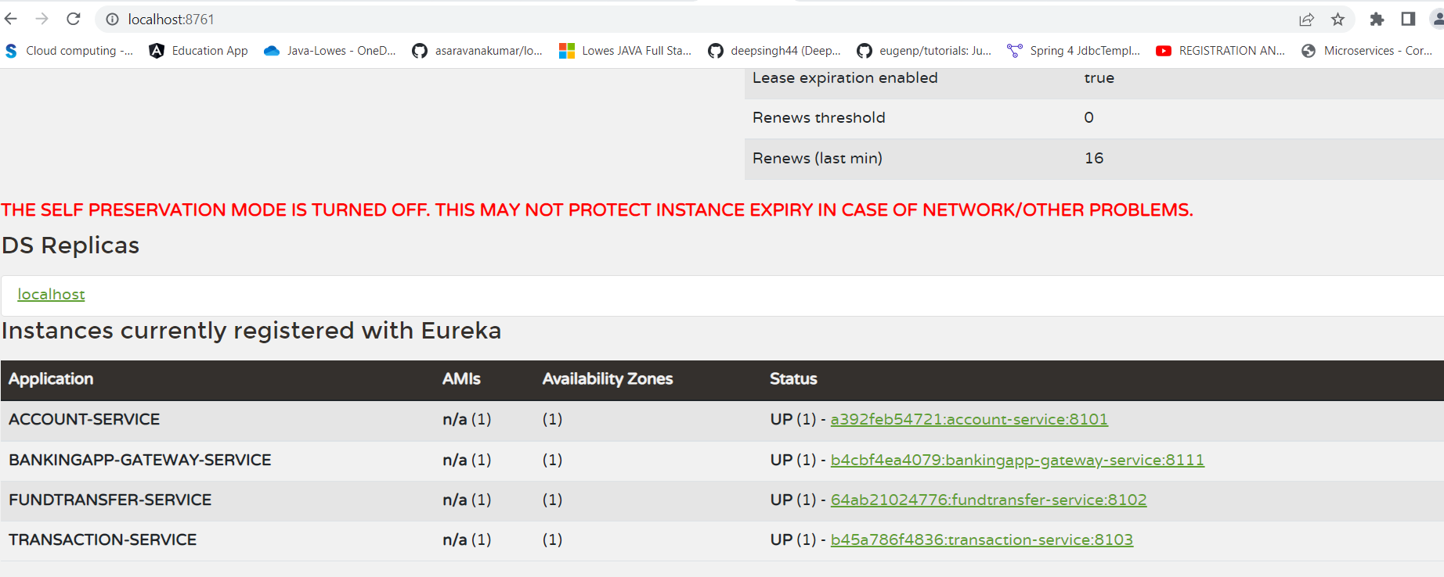

**Dockerization on local desktop**

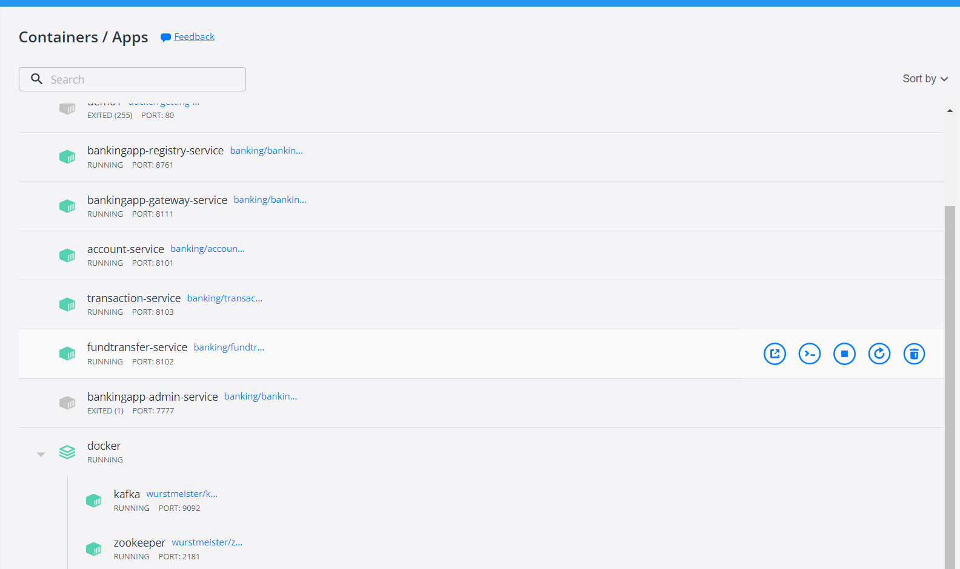

**Docker Hub services**

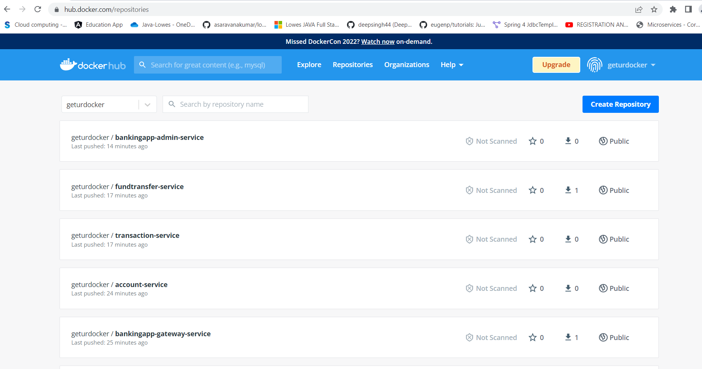

**Banking App Admin Service**

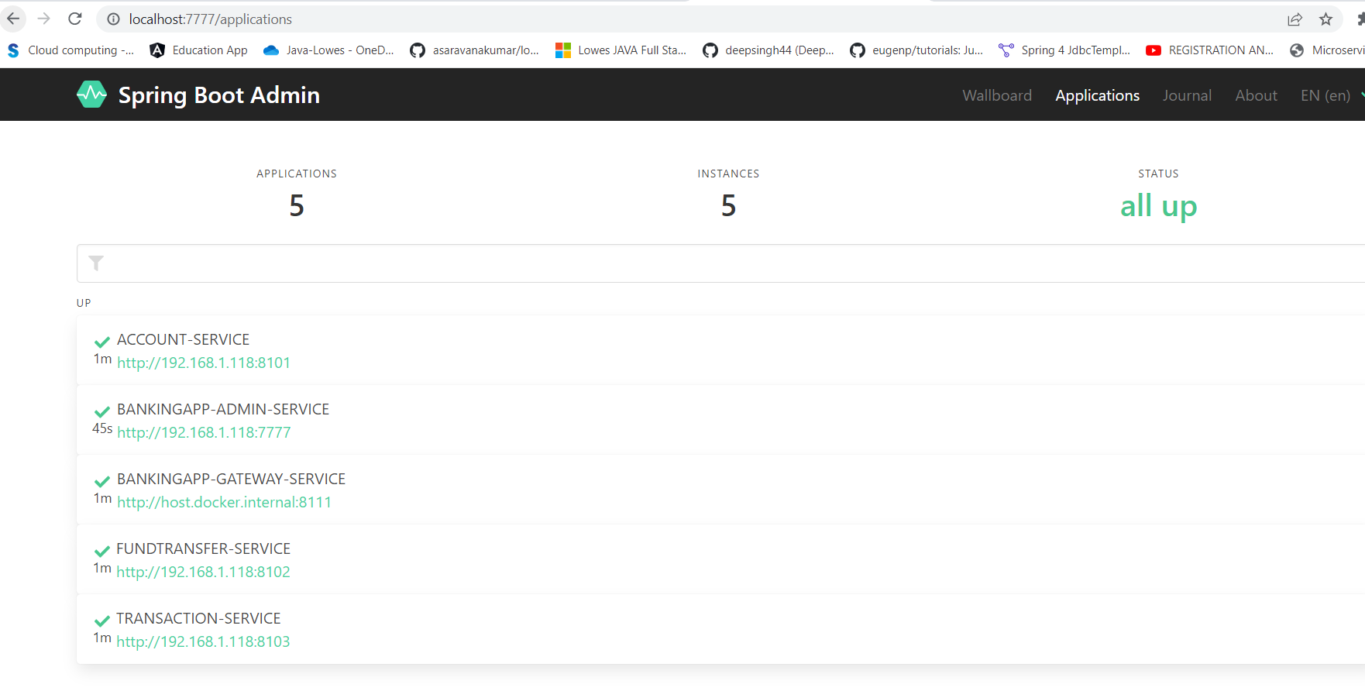

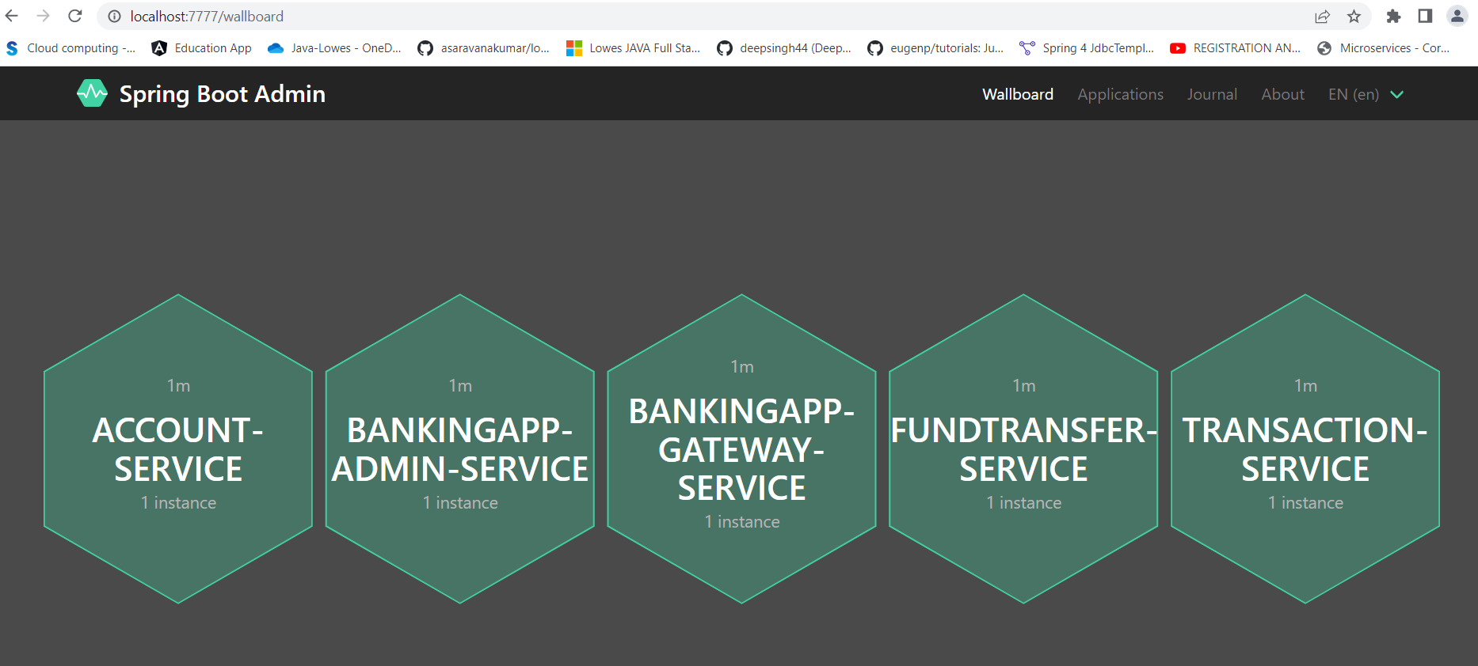

**Deployment on Kubernetis**

